Name: Charalampos SKOULIKARIS
E-mail: hskoulik@civil.auth.gr
Institution: Aristotle University of Thessaloniki
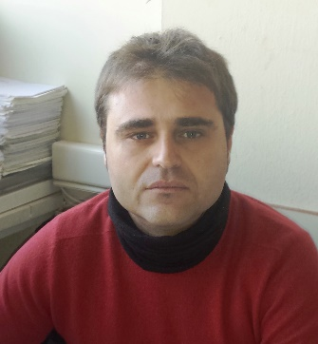 | PhD, Research Associate at the Civil Engineering Department, AUTh. Joint PhD in water resources management of AUTh, Greece, and Ecole des Mines de Paris - Paris Tech, France.Secretary General of the UNESCO Chair and Network INWEB. Research associate in more than 17 national and international research projects, with 8 of them to be related with transboundary water resources management issues in the Balkans, Middle East and Maghreb area. Participation in 1 Tempus and 2 Erasmus + projects. Author of more than 50 scientific articles.
References (max. 5 relevant references)
- Skoulikaris, Ch. & Ganoulis, J. (2017). Multipurpose hydropower projects economic assessment under climate change conditions. Fresenious Environmental Bulletin, 26 (9), 5599-5607.
- Reil, A., Skoulikaris, Ch., Alexandridis, T. K., and Roub, R. (2016). Evaluation of riverbed representation methods for 1D flood hydraulics model. Journal of Flood Risk Management. DOI: 10.1111/jfr3.12304 (in press)
- Anagnostolpoulou, C., Tolika, K., Skoulikaris, Ch. & Zafirakou, A. (2016). Climate Change Assessments Over a Greek Catchment Using RCM’s Projection. In: Karacostas T., Bais A., Nastos P. (eds) Perspectives on Atmospheric Sciences. Springer Atmospheric Sciences. Springer, Cham, 655-661, DOI10.1007/978-3-319-35095-0_93.
- Alexandridis T. K., Monachou S., Skoulikaris Ch., Kalopesa E., and Zalidis G. (2014) Investigation of the temporal relation of remotely sensed coastal water quality with GIS modelled upstream soil erosion, Hydrol. Process., doi: 10.1002/hyp.10373.
- Skoulikaris, Ch., Ganoulis, J., Karapetsas, N., Katsogiannos, F. & Zalidis, G. (2014) Cooperative WebGIS interactive information systems for water resources data management. In: Hydrology in a Changing World: Environmental and Human Dimensions (T. Daniell et al. Eds), IAHS Publ 363, 342–347. IAHS, Wallingford, UK.

This project has been funded with support from the European Commission. This publication reflects the views only of the author, and the Commission cannot be held responsible for any use which may be made of the information contained therein.

